Your Paper Title Here (Use Title Case-font size 16 and Bold)
^{1*}First Author, ²Second Author, ³Third author

¹Johns Hokpins Bloomberg School of ………
615 N Wolfe St, Baltimore, MD 21205, USA
*author1@email.com

²Bristol Medical School,
United Kingdom
author2@email.com

³Faculty of Medicine Atma Jaya Catholic University,
Jakarta, DKI, Indonesia
author3@email.com

Instructions
These instructions provide you guidelines for preparing papers for Stratford Journals. Use this document as a template and as an instruction set. Please submit your manuscript through Online Submission or stratfordjournals.org
Abstract
The abstract to include;
Purpose of the study,
Short introduction of problem statement,
Method/methodology,
Results of the study,
Conclusion and policy recommendation

Keywords: about four to six key words separated by commas and in italic.

Introduction
When you submit your paper print it in one-column format, including figures and tables. In addition, designate one author as the “corresponding author”. This is the author to whom proofs of the paper will be sent. Proofs are sent to the corresponding author only.

Page Size and Layout
Set your page as A4 and margins as follows:
- Left Margin 1.5"
- Right Margin 1"
- Top Margin – 1"
- Bottom Margin – 1"
You should use Times Roman of size 12 for all fonts in the paper and single spaced.

Title, Authors, Body Paragraphs, Sections Headings and References

Title and authors
The title of the paper is centered below the top of the page in 24 point font. Right below the title (separated by single line spacing) are the names of the authors. The font size for the authors is 12pt.

Body paragraphs
The main text for your paragraphs should be 12pt font. Use block format paragraphs.

Figures
Place the title of the Figure below the chart. For Example:
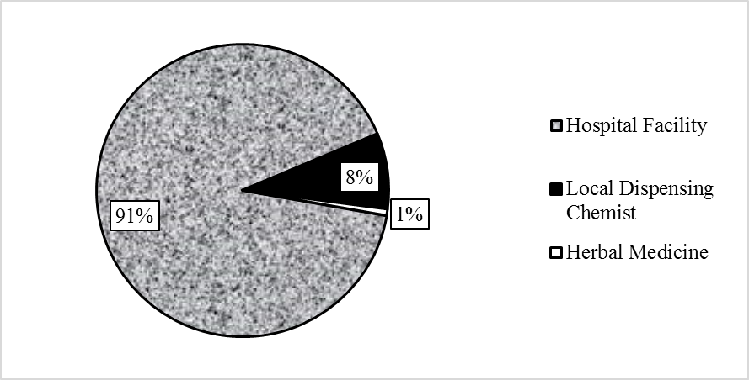
Figure 1: (Below the figure)

Tables (Above the figure)
Place table titles above the tables. For example:

Table 1: APA style-Heading 4
Reason for choice: | Source of malaria treatment
Reason for choice: | Hospital | Drugs from chemist | Herbal Medicine
Better facilities | 197 (76.4%) | - | -
Cheaper | - | 13 (54.2%) | 1 (100%)
Only option | 1 (0.4%) | 8 (33.3%) | -
Quality and cheaper drugs | 47 (18.2%) | - | -
Was Very Sick | 11 (4.3%) | 3 (12.5%) | -

Sections headings
Section headings come in several varieties:
- first level headings: 1. Heading 1
- Second level: 1.2. Heading 2
- third level: 1.2.3 Heading 3
- forth level: (a) Heading 4 (Tables)
- fifth level: (1) Heading 5 (Figures)

References
APA style, MLA or Chicago (N/B: Be consistent with a style of referencing you choose)

Summary guide for preparing a manuscript
Title
Authors’ details
Abstract
Key word
Introduction
Problem statement
Objective (s)
Literature review (theoretical and Empirical literature)
Conceptual framework (Not necessary but you can insert if your document has it)
Methods/Procedures/Methodology
Key result and findings
Summary
Conclusion
Recommendations (for practice/ policy/ Areas for further research).

Number of Pages for the Article
The standard number of pages of the article should be between 8 pages to 20 pages (font size 12 Times New Roman, single spaced).

